8. MedCare Hospital has developed an online appointment booking system that allows patients to book appointments with doctors from various specialties at their convenience. Key functionalities include user registration and login, searching hospitals and doctors by location and specialty, viewing doctor ratings and reviews, booking and cancelling appointments, viewing appointment history and status, updating personal details, and receiving appointment reminders via email or SMS. Admins can manage appointments and doctors and view appointment statistics and rating details. Hospitals can register, log in, create and update hospital details and location, and patients can view the hospital on Google Maps. The system protects patient information and reduces waiting time and paperwork.
AIM
To design a simple Hospital Appointment Booking webpage where patients can search for doctors by location and specialty, view ratings and map links, book an appointment on a preferred date and time, and check the appointment status.
HTML CODE
<!DOCTYPE html>
<html lang="en">
<head>
<meta charset="UTF-8">
<meta name="viewport" content="width=device-width, initial-scale=1">
<title>MedCare Hospital Appointment Booking</title>
<style>
body { font: 16px Arial, sans-serif; max-width: 650px; margin: 40px auto; padding: 20px; color: #222; background: #f0f7fb; }
h1 { color: #0b6e99; }
section { border: 1px solid #bcdcea; background: #fff; border-radius: 8px; padding: 20px; margin: 20px 0; }
input, select, button { padding: 10px; margin: 6px 0; width: 100%; box-sizing: border-box; }
button { background: #0b6e99; color: #fff; border: 0; border-radius: 6px; cursor: pointer; }
.doc { border-bottom: 1px solid #ddd; padding: 8px 0; }
.ok { color: #146c43; font-weight: bold; }
</style>
</head>
<body>
<h1>MedCare Hospital</h1>

<section>
<h2>Search Doctors</h2>
<select id="loc">
<option>Chennai</option><option>Coimbatore</option><option>Madurai</option>
</select>
<select id="spec">
<option>Cardiology</option><option>Dermatology</option><option>Pediatrics</option>
</select>
<button onclick="searchDoctors()">Search</button>
<div id="list"></div>
</section>

<section>
<h2>Book Appointment</h2>
<form id="bookForm">
<input id="pname" placeholder="Patient name" required>
<select id="doctor"></select>
<input id="date" type="date" required>
<select id="time">
<option>09:00 AM</option><option>11:00 AM</option><option>04:00 PM</option>
</select>
<button type="submit">Book Appointment</button>
</form>
<p id="bookResult"></p>
</section>

<section>
<h2>Appointment Status</h2>
<input id="ref" placeholder="Enter appointment ID" maxlength="6">
<button onclick="checkStatus()">Check Status</button>
<p id="refResult"></p>
<small>Sample appointment ID: MC2001</small>
</section>

<script>
const doctors = [
{name: "Dr. Ravi Kumar", spec: "Cardiology", loc: "Chennai", hospital: "MedCare Adyar", rating: 4.8},
{name: "Dr. Anitha Rao", spec: "Cardiology", loc: "Chennai", hospital: "MedCare T. Nagar", rating: 4.5},
{name: "Dr. Suresh B.", spec: "Dermatology", loc: "Coimbatore", hospital: "MedCare RS Puram", rating: 4.6},
{name: "Dr. Meera Nair", spec: "Pediatrics", loc: "Madurai", hospital: "MedCare Anna Nagar", rating: 4.7}
];
function searchDoctors() {
const loc = document.getElementById("loc").value;
const spec = document.getElementById("spec").value;
const found = doctors.filter(d => d.loc === loc && d.spec === spec);
document.getElementById("list").innerHTML = found.length ? found.map(d =>
`<div class="doc"><b>${d.name}</b> (${d.spec}) - ${d.hospital}<br>
Rating: ${d.rating}/5 | <a href="https://maps.google.com/?q=${d.hospital}" target="_blank">View map</a></div>`).join("")
: "No doctors found.";
document.getElementById("doctor").innerHTML = found.map(d => `<option>${d.name} - ${d.hospital}</option>`).join("");
}
document.getElementById("bookForm").addEventListener("submit", function(event) {
event.preventDefault();
const out = document.getElementById("bookResult");
out.className = "ok";
out.textContent = `Appointment booked for ${document.getElementById("pname").value} with ` +
`${document.getElementById("doctor").value} on ${document.getElementById("date").value} ` +
`at ${document.getElementById("time").value}. ID: MC2001. Reminder will be sent by email/SMS.`;
});
function checkStatus() {
const id = document.getElementById("ref").value;
document.getElementById("refResult").textContent = id === "MC2001"
? "Status: Confirmed - Dr. Ravi Kumar, MedCare Adyar, 11:00 AM"
: "Appointment not found.";
}
searchDoctors();
</script>
</body>
</html>

OUTPUT
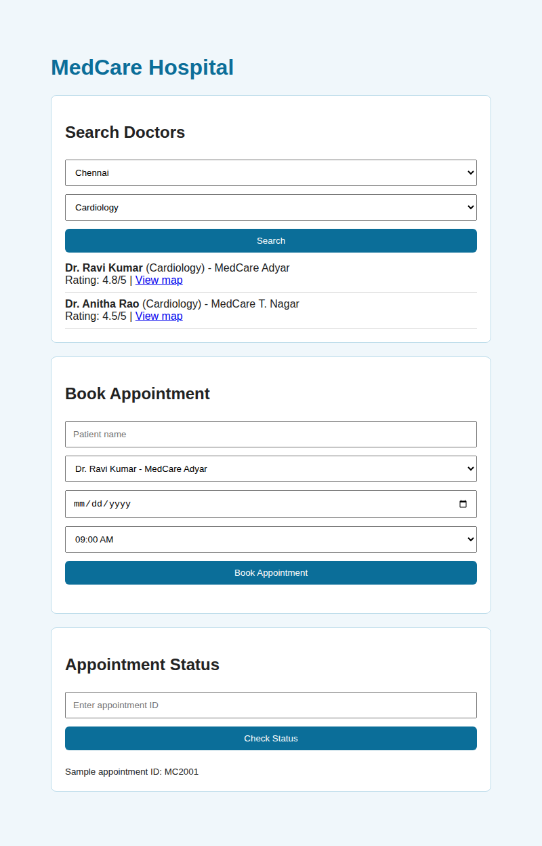  Output 1: Doctor search by location and specialty | 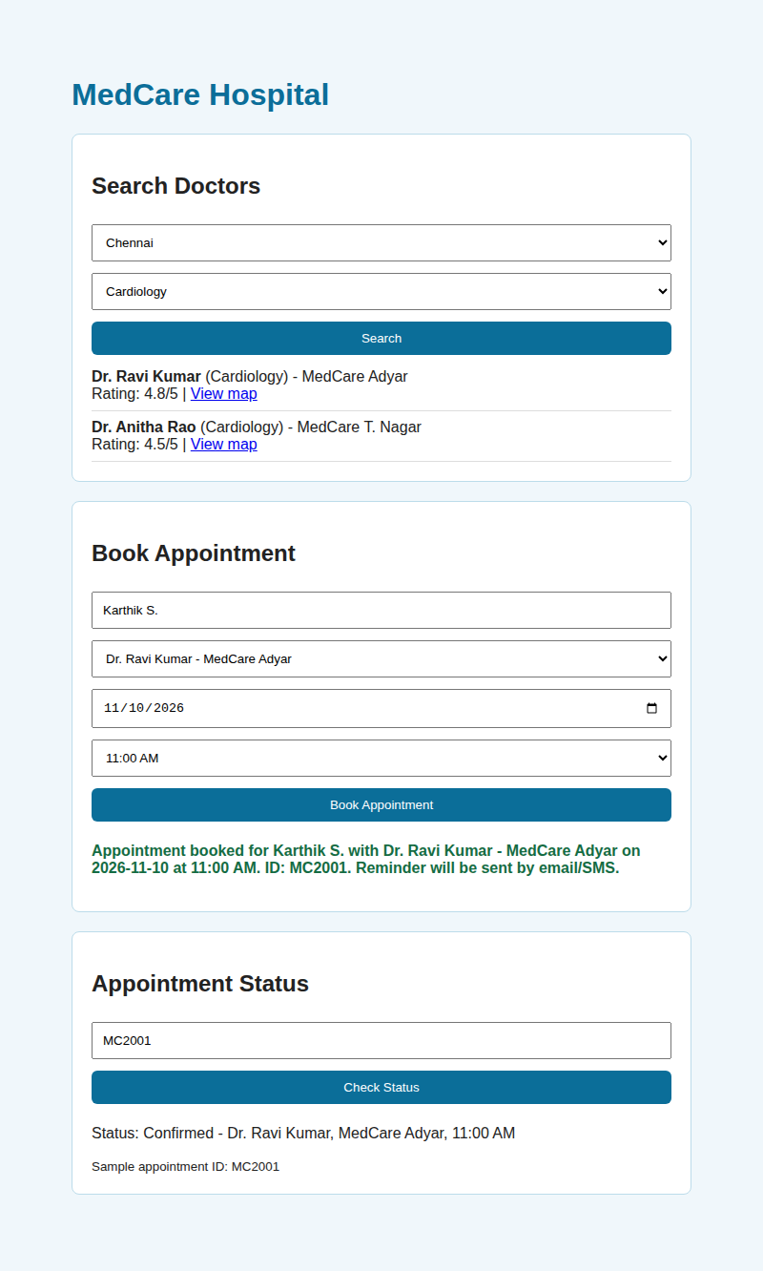  Output 2: Appointment booked and status checked
RESULT
The Hospital Appointment Booking webpage was created successfully. It filters doctors by location and specialty, shows their ratings with a map link, books an appointment with a confirmation message, and displays the status of the sample appointment ID MC2001.

